Муниципальное бюджетное общеобразовательное учреждение
г. Новосибирска
«Лицей №81»
Калининский район

Секция: английский язык

Исследовательский проект
“People of the future”

Выполнили: Азаров Глеб Сергеевич,
Рыданова Надежда Дмитриевна,
ученики 4А класса
Руководитель: Азарова Елена Павловна,
учитель английского языка

Новосибирск
2020
CONTENTS
INTRODUCTION……………………………………………………………….  THEORETICAL PART………………………………………………………….  1. “The garbage problem” of Russia……………………………………………..  1.1. Waste recycling……………………………………………………………..  1.2. Garbage reform in Russia……………………………………………………  2. Study of the international experience of waste recycling on the example of Japan……………………………………………………………………………..  2.1. Waste recycling in Japan……………………………………………………  2.2. The usage of recycled waste…………………………………………………  PRACTICAL PART……………………………………………………………..  3. Environmental program “People of the future”……………………………….  3.1. Carrying out the program “People of the future” in Lyceum No. 81………..  3.2. Results of the program “People of the future”……………………………….  CONCLUSION…………………………………………………………………..  REFERENCE LITERATURE…………………………………………………...  Annex No. 1 Photos from the English lessons and class hours…………………..  Annex No. 2 Photos from the garbage collection by the Association…………….  Annex No. 3 Photos of our awards………………………………………………..  Annex No. 4 Photos from the rewarding………………………………………….  Annex No. 5 Analysis of the program results…………………………………….  Annex No. 6 Our articles………………………………………………………… | 3  5  5  5  5  7  7  8  10  10  10  11  13  14  15  16  17  18  19  22

INTRODUCTION

The development of technological progress, the increase in population and the irrational use of natural resources of our planet have led to serious problems in the field of ecology.
The relevance of our topic is determined by the fact that waste is one of the main modern problems, which carries a potential danger to human health, as well as a danger to the natural environment. Nature until a certain time coped with the processing of waste itself, but there are new materials, the processing of which in a natural way can last more than one hundred years, and nature cannot bear the burden anymore.
Last year our 3A class of Lyceum №81 was accepted into the ranks of the pioneers. As pioneers, we thought about what we can do to improve the current situation with garbage in our country. Our teacher, Elena Pavlovna, always tells us that if we want to change the world we must start with ourselves. Therefore, the main purpose of our work is to study the international experience in solving the problems of garbage processing and to make others aware of the importance of this issue, to convince them of the necessity of waste sorting as an initial stage of its processing.
Tasks:
1. To study “the garbage problem” of Russia.
2. To study the experience of other countries in this sphere on the example of Japan.
3. To attract the attention of young people to “the garbage problem” of Russia and show them the ways of solving it on the example of Japan.
4. To conduct an environmental program in Lyceum No. 81.
5. To carry out the analysis of the received results on collecting the sorted garbage depending on age of children.
The hypothesis of our research is that modern youth is ready to take an active part in solving “the garbage problem”.
Object of research: ways to solve “the garbage problem” in our country.
Subject of research: different types of recyclable, non-recyclable waste.
During our survey, we used the following research methods:
- Data collection.
- Observation.
- Questioning.
- Analysis.

THEORETICAL PART
1. “The garbage problem” of Russia
1.1. Waste recycling

According to scientists, each of the inhabitants of the Earth accounts for about 1 ton of garbage per year and this number is growing all the time. The planet is literally filled with garbage. Solid waste is diverse: wood, cardboard and paper, textiles, leather and bones, rubber and metals, stones, glass and plastics.
Unfortunately, at present the problem of recycling particularly affects Russia. The approach to garbage collection in our country is much different from European methods. In many European countries, voluntary waste collection and recycling centres are encouraged. For example, in England, people get quite a good increase in wages, just handing over to the recycling centers of their garbage and garbage collected on the street. Abroad, it is customary to sort garbage in accordance with the type of waste. You will inevitably be fined if you throw metal or plastic into the glass container. So the recycling process becomes much easier. In Russia, recycling is considered completed when various kinds of waste come to the landfill. Huge hundreds of hectares of polluted land become uninhabitable and emit harmful smell.
The environmental problem of garbage is becoming frightening, because every day the amount of unprocessed waste only increases, and no one can give clear instructions to combat this problem.

1.2. Garbage reform in Russia

In Russia, the problem of handling household waste at the normative level has not been raised for a long time. This has led to an unauthorized expansion of landfills across the country with poisoning of environment and risk of infectious diseases for the population. The garbage reform was developed in 2017. The whole of 2018 was set aside to prepare for its implementation. On January 1, 2019, the garbage reform came into force.
The main principals of garbage reform are as follows:
* The principle of separate collection and removal of garbage is approved.
* Licenses to install waste sorting tanks are cancelled.
* Garbage collection and removal service will be provided only by specialized regional operators approved by state authorities.
* The tariff for the export of solid waste will be set by regional operators according to the number of registered residents.
* All questions on the location of landfills and waste burning plants should be agreed with the population of the regions.
The main problem of the new reform is the lack of a clear program of solid waste disposal throughout the country. The requirements and conditions for the construction of waste incineration plants, which can be applied in different parts of Russia, have not been developed. Containers for separate garbage collection and landfills have not yet been installed all over Russia.
However, the main problem in our opinion is not that people do not know about the new reform, but that they do not want to accept it. Most people do not want to sort garbage and even more so to pay for its removal and processing, not understanding the depth of “the garbage problem” in our country.

2. Study of the international experience of waste recycling on the example of Japan
2.1. Waste recycling in Japan

As a positive international experience of waste recycling, we would like to consider the experience of Japan.
The Japanese have come up with many ways to recycle garbage, and today it is used as a secondary raw material for the production of many things. This helps to solve:
- Environmental problem.
- Problems of absence of some minerals.
- The problem of lack of the territory.
The Japanese have developed technologies for processing almost all garbage into something useful. For that, they divide all garbage into categories, such as “burned” or “not burned” and “recyclable” or “not recyclable”.
In order to make household garbage easier to eliminate or recycle, it was decided to sort it.
The Japanese sort the garbage into the following containers:
- All organic waste, including kitchen waste.
- Paper packaging, only clean paper and packaging marked with a special sign.
- Plastic packaging marked with a special sign.
- Aluminum and steel cans.
- Glass, which is divided into three groups: white, brown-black and all other colors.
- Plastic bottles marked with a special sign.
All these types of garbage are thrown into special separate containers, which are installed near residential buildings. It is possible to throw out such garbage marked with special signs free of charge as producers have already payed for its recycling. If the product does not have such sign, then the final consumer should pay for its recycling.
In addition, the types of waste suitable for recycling in Japan include:
- White and colored boxes for products in which meat, fish, vegetables and other goods are sold.
- Tetrapacks.
The supermarkets that sell these products collect such garbage, and the Japanese go to throw garbage there.
In addition, recyclable garbage in Japan includes:
- Waste paper, which is divided into cardboard, printed products and just paper.
- Clothing, which must be pre-cut all metal and plastic elements and accessories: fasteners, buttons, clips.
Such garbage is collected in a specially designated place once a month.
Not recyclable garbage, or rather, garbage that needs to be divided into component parts for processing, the Japanese hand over only for money. Therefore, residents of Japan tend to sort as much of their garbage as possible in order to pay less for its recycling.

2.2. The usage of recycled waste

The Japanese use recycled garbage as efficiently as possible. For example, in the Bay, located in the South of the city of Kobe, an artificial island made of garbage with an area of 436 hectares called Port Island was poured.
There are several hotels, parks, sports and entertainment areas there. This is a great example of how you can thriftily treat the issue of solid waste recycling. The Japanese managed to solve both garbage and territorial problems at the same time.
Of course, the Japanese do not only make islands out of garbage. Sportswear, stationery, office furniture, school uniforms and other are made from recycled plastic bottles. Also, the Japanese process different types of glass, clay and porcelain, from which they make tiles used for paving streets and panels used for wall cladding. Production of building materials from garbage is well developed in Japan.
As for food waste not all of it is burned. Quite often, it is processed and used to make fertilizers necessary for agriculture.

PRACTICAL PART
3. Environmental program “People of the future”
3.1. Carrying out the program “People of the future” in Lyceum No. 81

After studying international experience in sorting, processing and recycling of garbage, as well as studying changes in Russian legislation on this issue, we decided that we need to share this knowledge with our classmates and pupils of other classes. Because if all people learn about the possibilities of recycling and start sorting garbage, there will be much less landfills in our city and in our country, and it will be possible to make a lot of useful things for people from the processed garbage.
The first thing we did was presenting this topic at the English language lessons dedicated to environmental problems to different classes of our Lyceum. It was hard for us to get around all the Lyceum classes, because there are so many of them. So, our supervisor Elena Pavlovna suggested us to address one class from each parallel starting from 2nd to 10th grade. Of course, we only spoke in English in grades 5 to 10. In elementary school, environmental issues are considered in the class hours, so we performed there in Russian.
We spoke in 9 classes: 2D, 3G, 4A, 5B, 6B, 7G, 8B, 9B and 10B. We talked about the garbage problem in our country, about the new reform and shared the collected information about the methods of sorting, collecting, processing and recycling of garbage, as well as about the possibilities of using recycled garbage. Our supervisor helped us prepare the report. The photos you can find in Annex No.1.
We told that the pioneers of our 4A have been sorting and handing over garbage for recycling since 2018. We have collected three types of garbage: waste paper, food-grade plastic bottle caps, and used batteries. Therefore, our report focused on the processing of these three types of waste. For example, according to found information in Poland they began to produce low-cost prosthetics for people's limbs from plastic bottle caps. In addition, in Japan, a whole island was poured out of recycled garbage; there are plans to hold the next Olympics there, and so on.
Students listened to us very carefully and agreed that the garbage problem of our country should be solved and it will most likely have to be solved by our generation – children who are still only schoolchildren.
We invited the children to take part in collecting and sorting garbage. All classes gladly agreed and began to collect garbage very actively.
Thus, a big environmental program started in our Lyceum. We thought it over and decided that we would call it “People of the future”, because this is how you can call people who care about the environment and ecology and understand the importance of recycling for our country and people's health. The students of our Lyceum showed themselves to be such, a new generation that cares about the future.
Our supervisor Elena Pavlovna, helped us to contact the Department of the All-Russian Association for Nature Protection in Novosibirsk, with Deputy Chairman Kovaleva Valeria Mikhailovna, who said that she would be very happy to cooperate with us.
When all the classes agreed to participate in our program, we came up with another idea – to conduct a study based on the results of the program. We decided to find out whether care about the environment comes with age and awareness of the depth of this problem in the older age of 9-10 grades or young, even very young children are people of the new generation, who have care about the environment “in the blood”.

3.2. Results of the program “People of the future”

The Association came to collect our garbage on 18.12.2019. In total, 584.6 kg of waste paper, 31.6 kg of caps and 20 kg of batteries were collected. The photos of this process you can find in Annex No.2. All classes participating in the program received certificates, and class teachers received letters of thanks from the Association. We also received a letter of honor from the Association. You can find in in Annex No. 3. Then we personally awarded three classes that collected the largest amount of garbage in each category with diplomas of the program “People of the future” and gave them sweet prizes: cakes and tea sets. The winners were: waste paper – 8B class, caps – 4A class and batteries – 10B class. The photos you can see in Annex No.4.
In Annex No. 5, you will find a table with the results of the program. We have also prepared charts to visualize the results and their detailed analysis. What conclusions can be drawn?
If we do not take into account the results of our 4A class of pioneers, the result is obvious, the older children, grades 8-10 collected much more garbage than the younger ones. Absolute leaders in the number of collected garbage is the 10th class. According to their head teacher, they actively collected stated types of garbage from the first day and even involve all their relatives and friends in this process.
Therefore, from all the above, we can conclude that the awareness of the depth of the problem of caring for nature and the future of humankind comes to people with age. Children 14-16 years old are ready to live in a new way today, we just need to teach them how to do it.
Our next goal was to include as many people as possible in our program. To do this, we wrote an article in our school press center based on the social network VKontakte. Then one more article in our school newspaper describing our action and calling on all interested classes to join our program. You can find them in Annex No. 6. We have scheduled the next “date of collection” for 01.06.2019.
In conclusion, I would like to note that we managed to receive 2338.4 rubles in return for our garbage. We decided to use these funds to create a book about the Hero of the Soviet Union Nikolai Nikitovich Mokriy.

CONCLUSION

Considering the problem of recycling, it is worth saying that despite the fact that the problem of garbage pollution begins with the manufacturer of the product, we hope that the garbage reform initiated in our country will lead to the creation of full-fledged garbage recycling centers. And garbage will turn into a source of fertilizers, cheap plastic prostheses and other useful things.
In addition, we are sure that a lot depends on an ordinary person in solving this problem. People should support the new law, while nowadays they are sure that they just waste their money paying for collection and recycling of garbage.
In our opinion, we managed to solve all the tasks set in our work. Namely:
1. We study the main issues of our country's “garbage problem”.
2. We have studied the experience of other countries in recycling, focusing in detail on recycling in Japan.
3. Through our reports in English lessons dedicated to ecology and class hours, we managed to interest young people in solving “the garbage problem” in Russia at least at the level of individual garbage sorting (see Annex No. 1).
4. We conducted an environmental program at Lyceum No. 81. We managed to collect a total of 636.2 kg of sorted garbage for further processing (see Annexes No. 2, 3, 4).
5. We analysed the results obtained for collecting sorted garbage depending on the age of children and found that children aged 14-16 years are already fully aware of the depth of the garbage problem and are ready to take up its solution (see Annex No. 5).
Moreover, we wrote two articles to draw the attention of other children who did not participate in the program to the stated problem (see Annex No. 6). And we succeeded. The next collection of sorted garbage is scheduled for 01.06.2020. We hope that we will be able to collect twice as much garbage.

REFERENCE LITERATURE

1. Алимкулов С. О., Алматова У. И., Эгамбердиев И. Б. Отходы – глобальная экологическая проблема. Современные методы утилизации отходов / Молодой ученый. – 2014. – №21. – С. 66-70.

2. Вести.Ru: «В Японии из отходов делают целые острова». Репортаж. / https://vesti.ru›doc.html?id=2854144

3. Всероссийское общество охраны природы. Официальный сайт. / https://voop.eco/nsk-reg/

4. Как обращаются с мусором в разных странах. Статья / http://skypolymer.com

5. «Миллион бутылок в минуту». Статья. / https://ecoidea.by/ru

6. «Мусорная реформа в России: что изменилось в 2019 году с 1 января». Статья. / https://Мусорная-реформа.рф

Annex No. 1
Photos from the English lessons and class hours
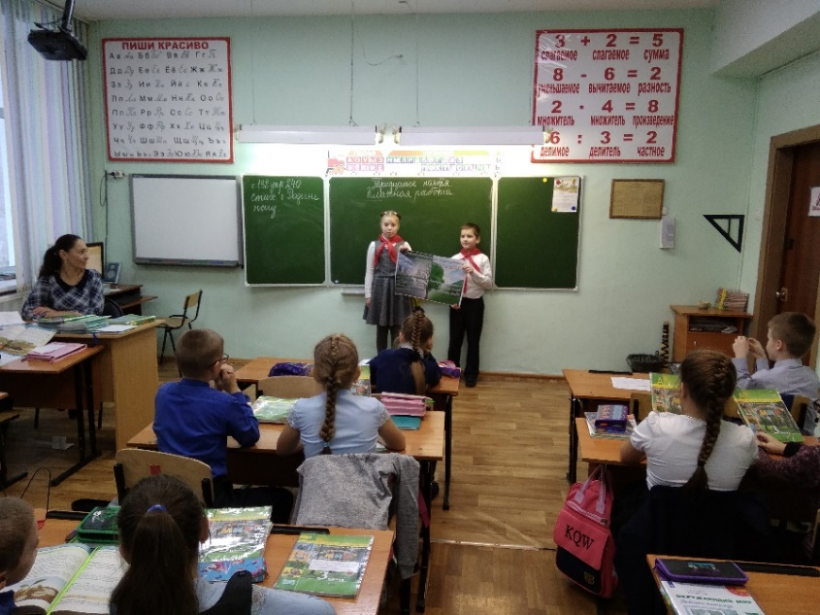
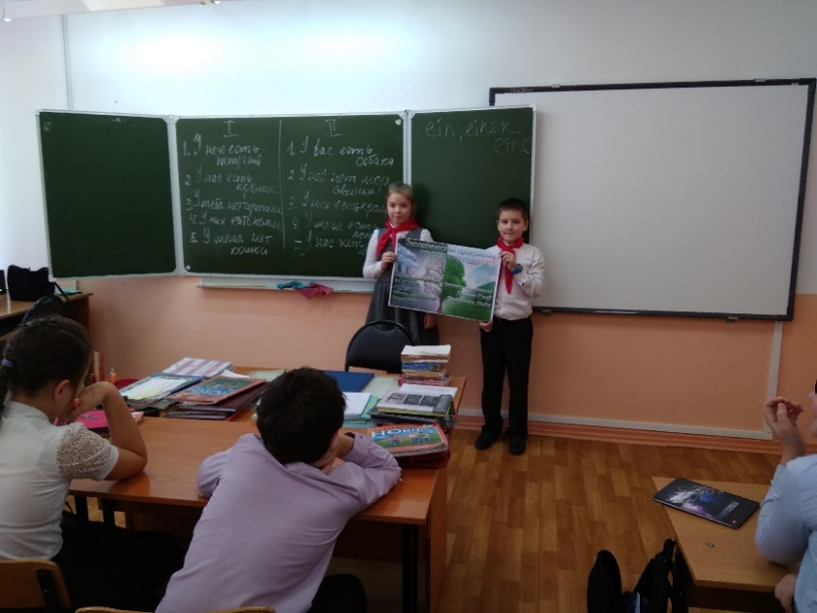
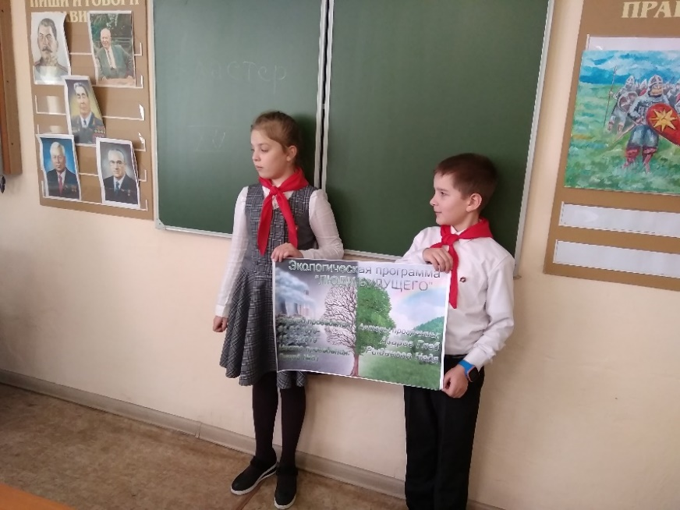
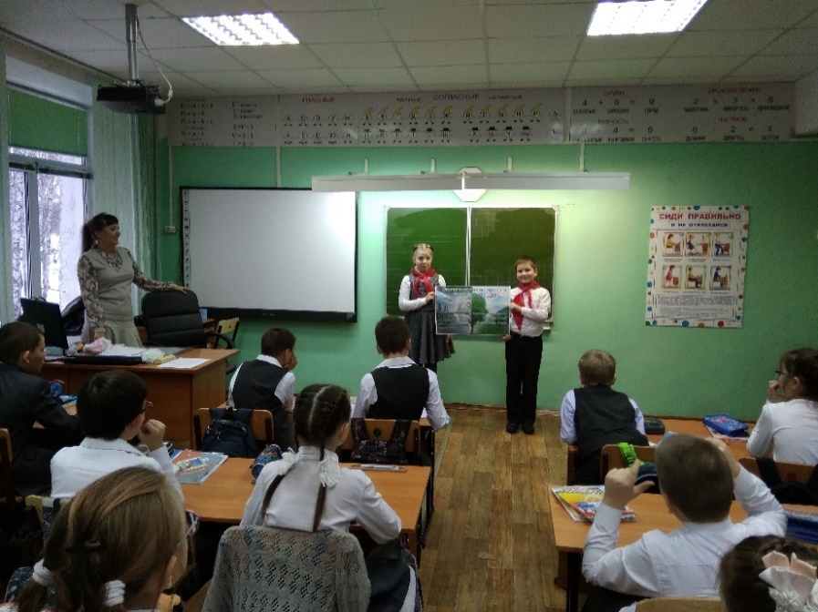
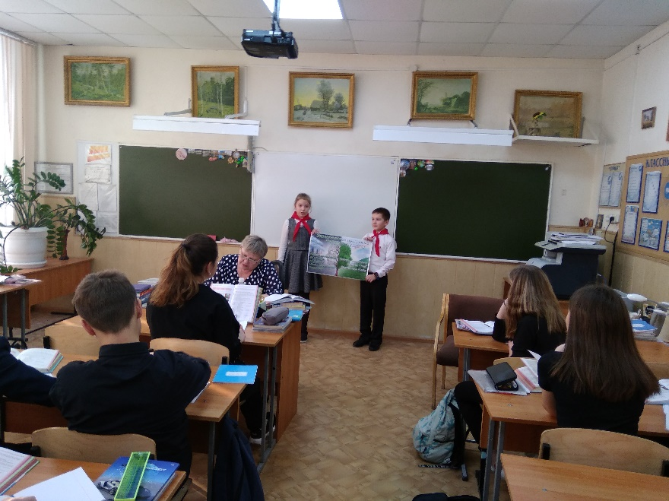
Annex No. 2
Photos from the garbage collection by the Association
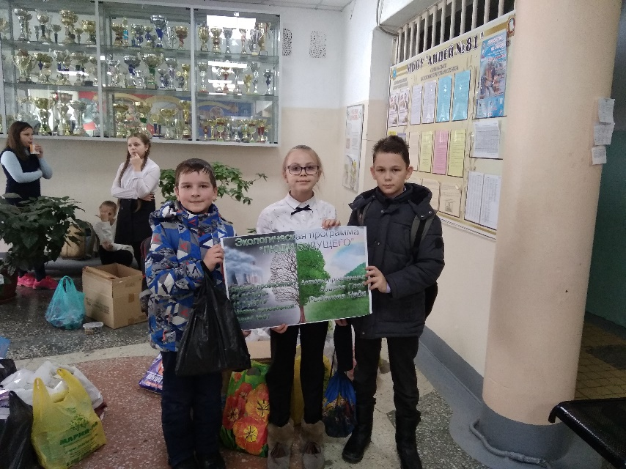

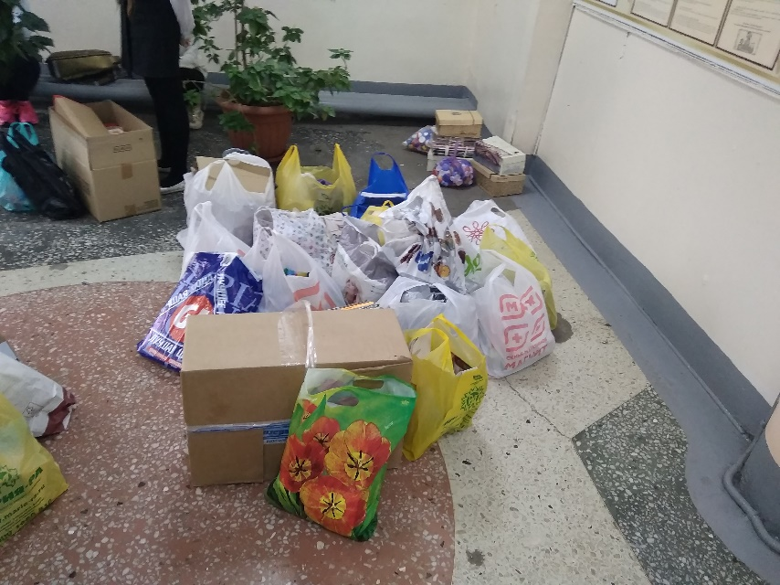
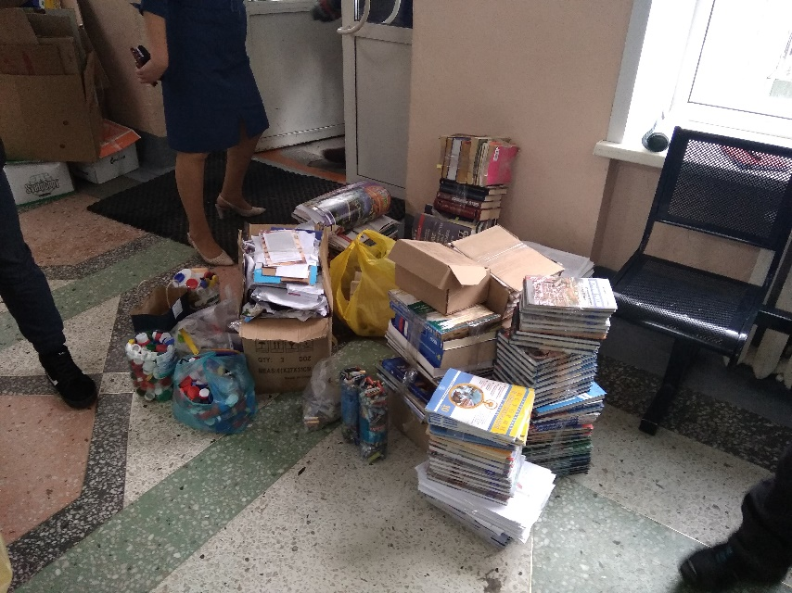
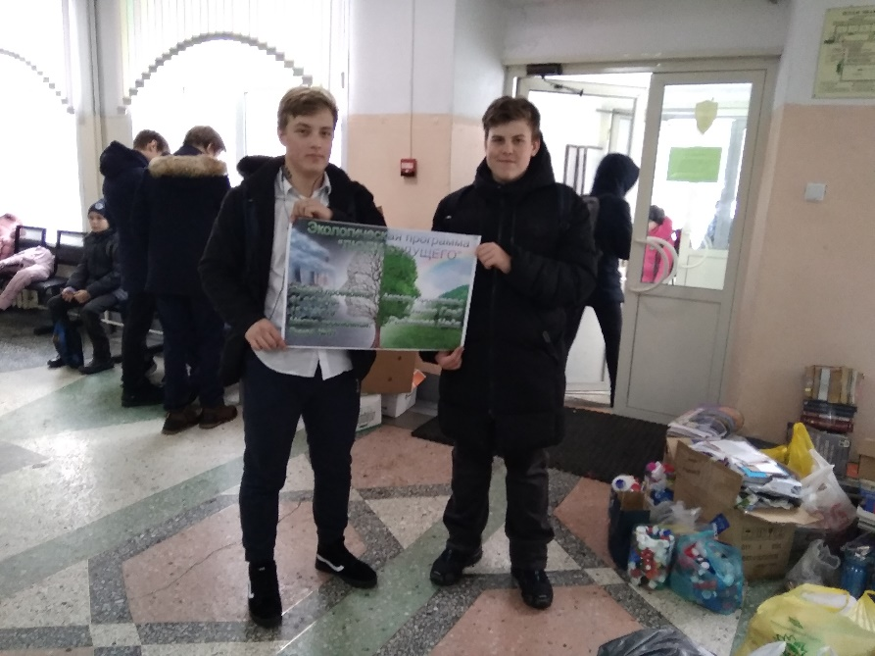
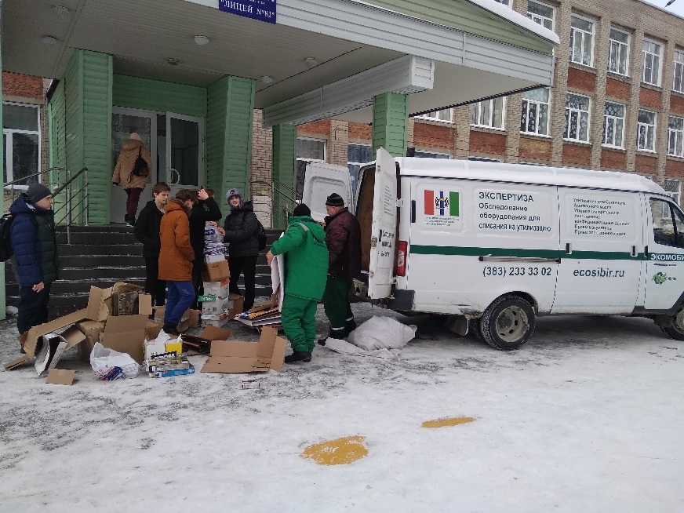

Annex No. 3
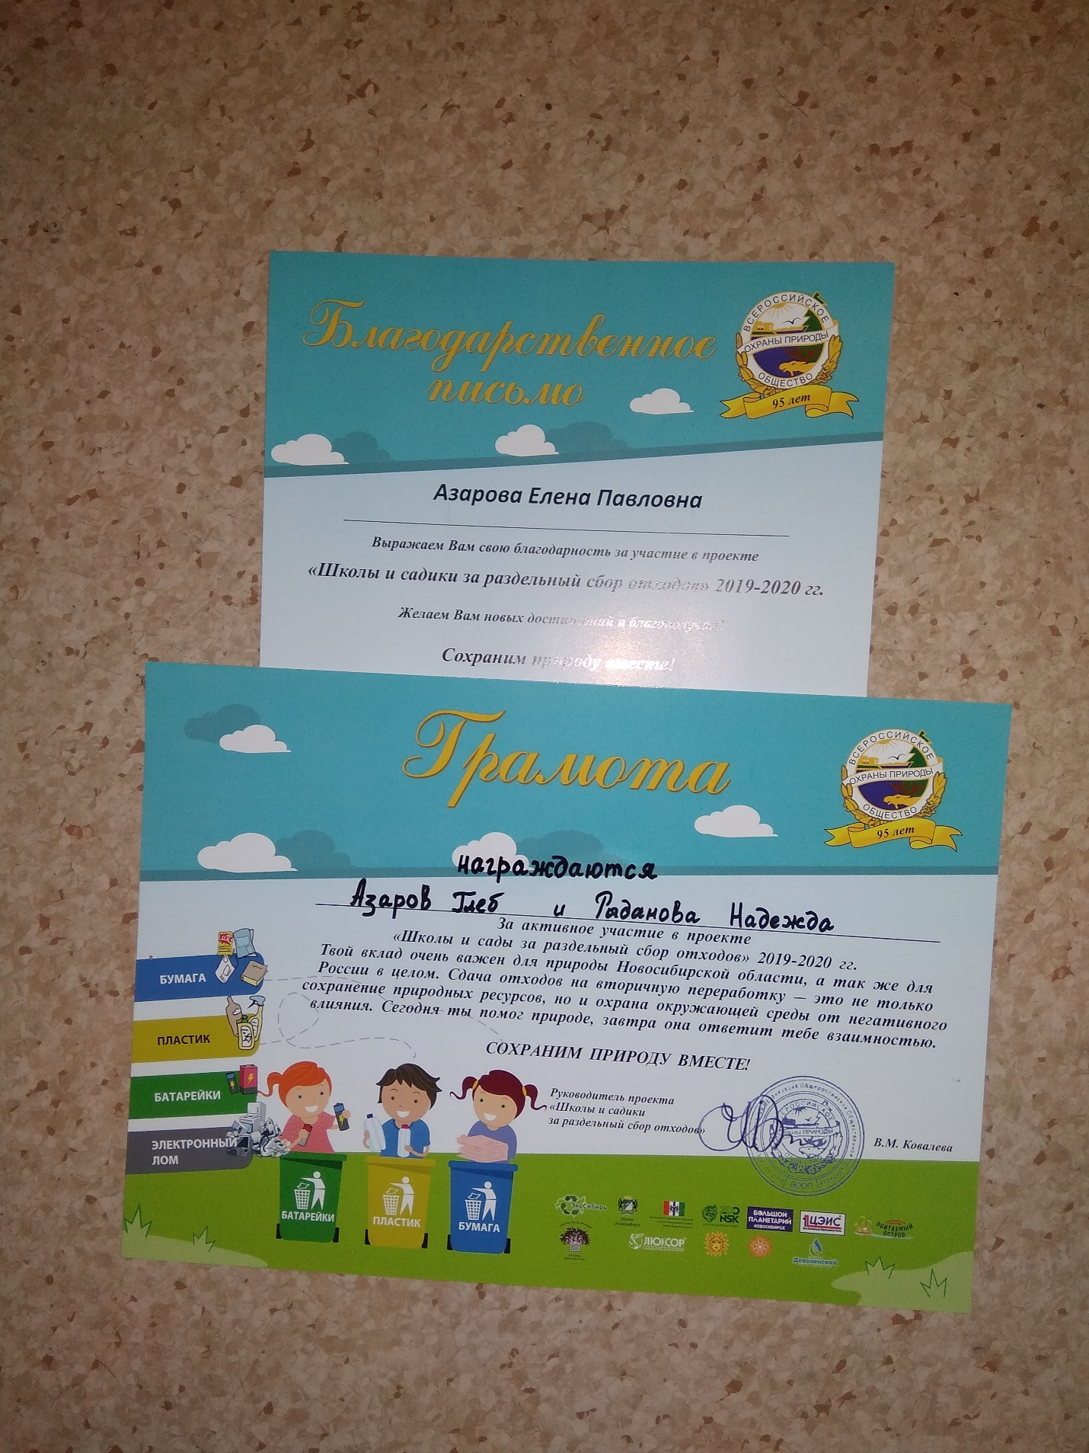
Photos of our awards

Annex No. 4
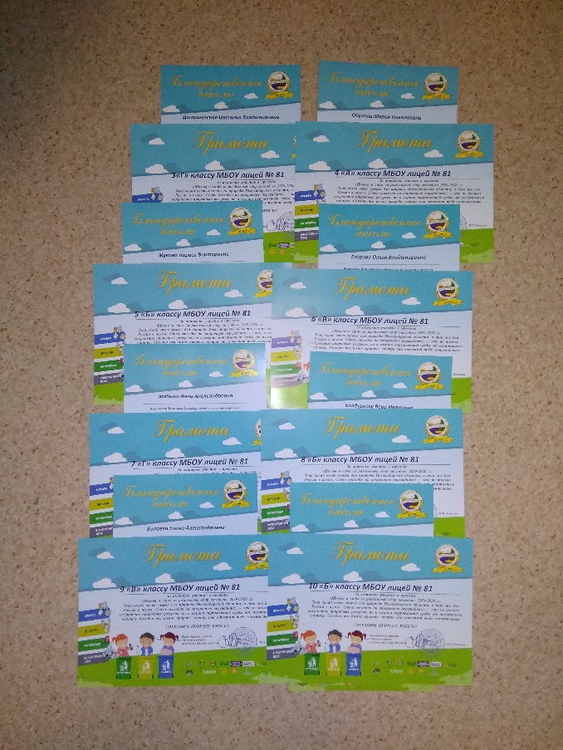
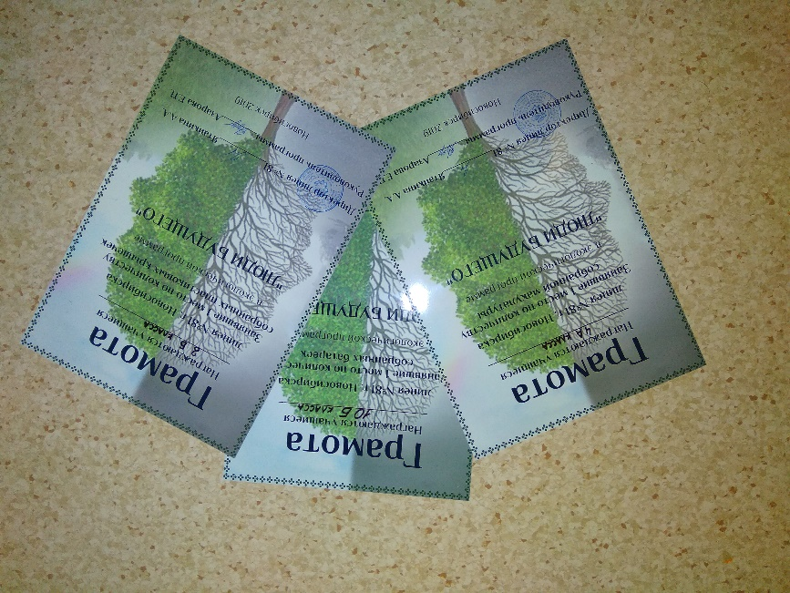
Photos from the rewarding
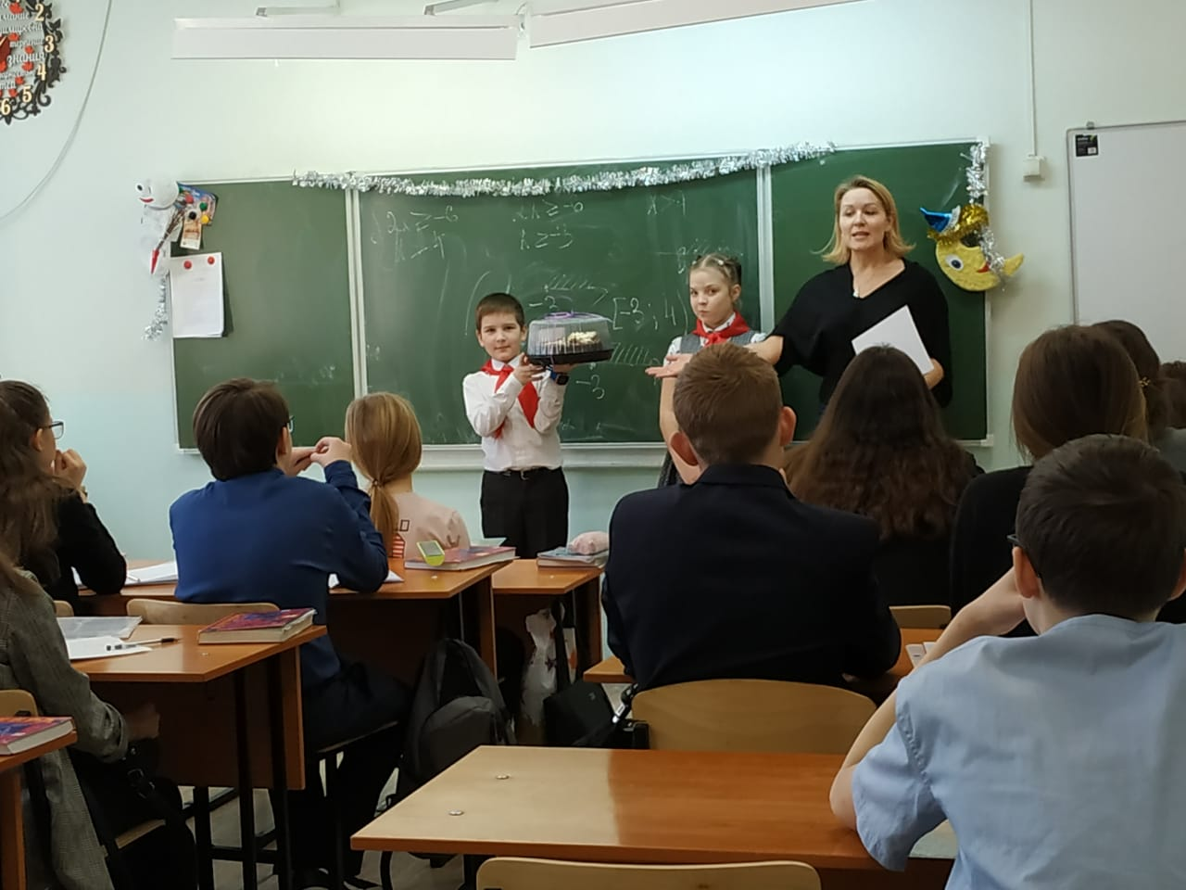
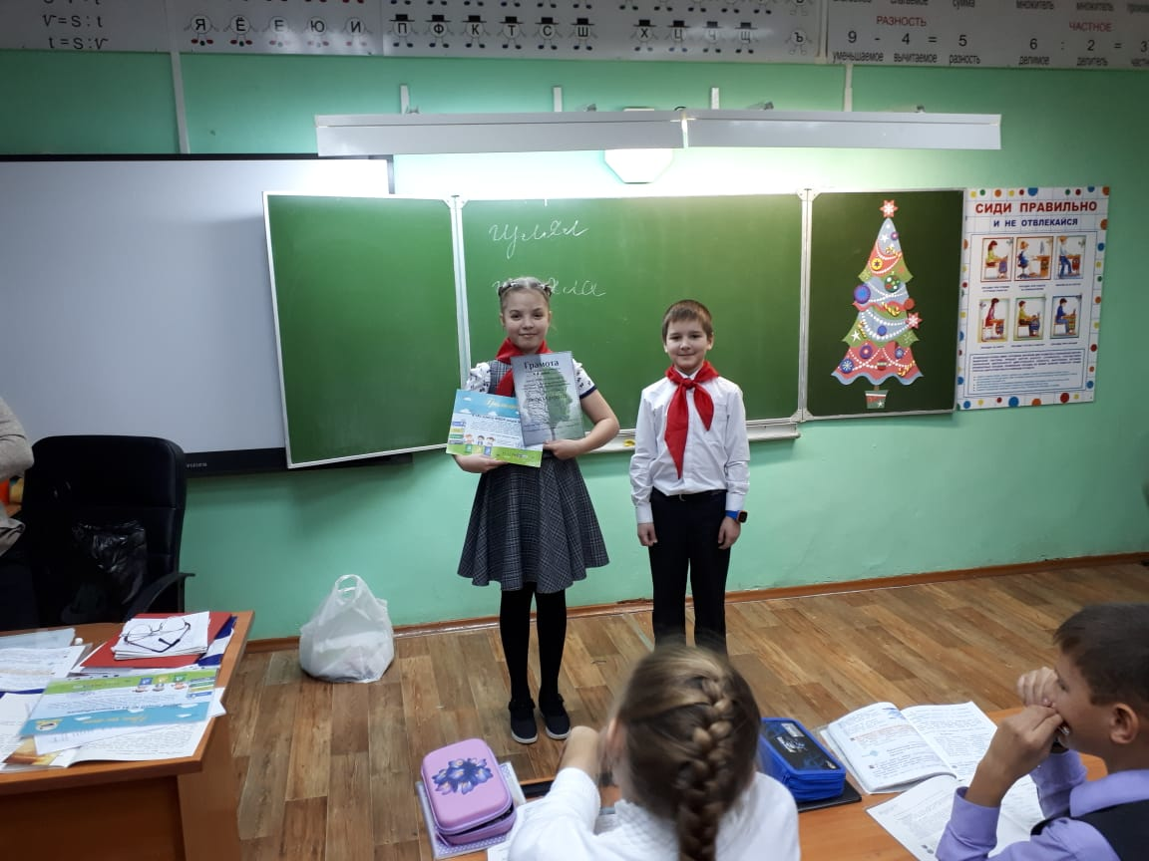
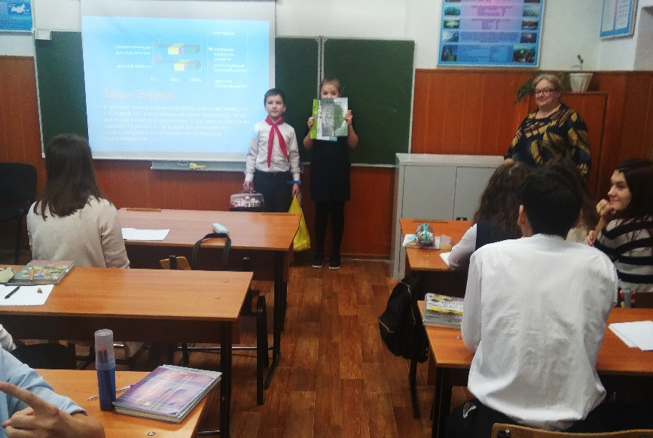

Annex No. 5
Analysis of the program results
Table 1. The Program results
Class | Waste paper, kg | Food-grade plastic bottle caps, kg | Used batteries, kg | Total for each class
2D | 18 | 1,50 | 0,50 | 20
3G | 15 | 1,80 | 1,30 | 18,1
4A | 82,2 | 15,05 | 5,70 | 102,95
5B | 40,2 | 4,10 | 0,80 | 45,1
6V | 18 | 1,25 | 1,00 | 20,25
7G | 47,6 | 1,00 | 2,50 | 51,1
8B | 135,7 | 0,30 | 0,40 | 136,4
9V | 101,15 | 2,00 | 1,65 | 104,8
10B | 126,75 | 4,60 | 6,15 | 137,5
Total in each category | 584,6 | 31,6 | 20 | 636,2

Fig. 1. Total results for each class in kilograms

Fig. 2. Total results for each class in percent

9 classes participated in the program, all classes collected garbage of three categories: waste paper, food-grade plastic bottle caps and used batteries (see Table 1). In total, 584.6 kg of paper was collected, of which the largest number was collected by the 8B class – 135.7 kg, on the second and third places 10B and 9B classes with 123.75 kg and 101.15 kg, respectively.
For plastic caps, the absolute leader was our 4A class, which collected 15.05 kg, 10B class is on the second place with a large margin, they collected 4.6 kg of caps.
As for batteries 10B class is on the first place, they collected 6.15 kg of batteries. Our 4A class is on the second place with a result of 5.7 kg.
In the overall standings, all three first places are taken by the senior classes: 10B is on the first place with a result of 137.5 kg, 8b class is on the second place with a result of 136.4 kg and 9B class is on the third place with a result of 104.8 kg. Students of our 4A class come slightly behind them with a result of 102.95 kg. It must be noted here that our pioneer class was not a newcomer in garbage collection, so it would be wrong to rely on its results in our analysis. So, as figure 2 shows us, the 3 senior classes collected 59% of all garbage, the share of each of them is about 20% of the total volume. While the contribution of primary school students (2-3 grades) is minimal, about 3% for each class. A little more garbage – 7-8% of the total amount was collected by middle-level students.
In General, the program can be considered successful, as each class has contributed to the overall result. However, the table and figures clearly demonstrate the absolute advantage of older students in terms of the amount of garbage collected and the lack of activity in collecting of younger students. This means that we need to work more with kids, explain to them the benefits of sorting garbage, remind them of the timing and order of collection.

Annex No. 6
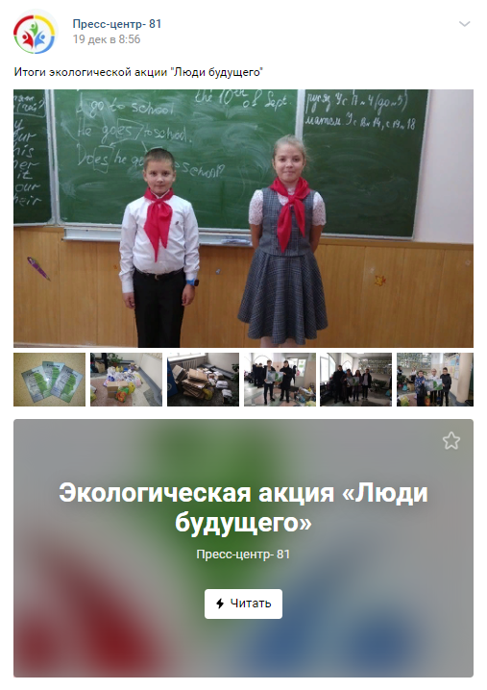
Our articles

